Introduction to Child Wellbeing
Raising awareness about the concept of children’s wellbeing to all adults

It is important to recognise what we mean by child wellbeing. As part of Scotland’s national approach to ‘Getting it Right for Every Child’ (GIRFEC), the wellbeing wheel demonstrates the eight indicators that are believed to be essential for a child or young person’s overall wellbeing. The eight indicators are often referred to using the acronym SHANARRI, which stands for Safe, Healthy, Achieving, Nurtured, Active, Respected, Responsible, Involved.

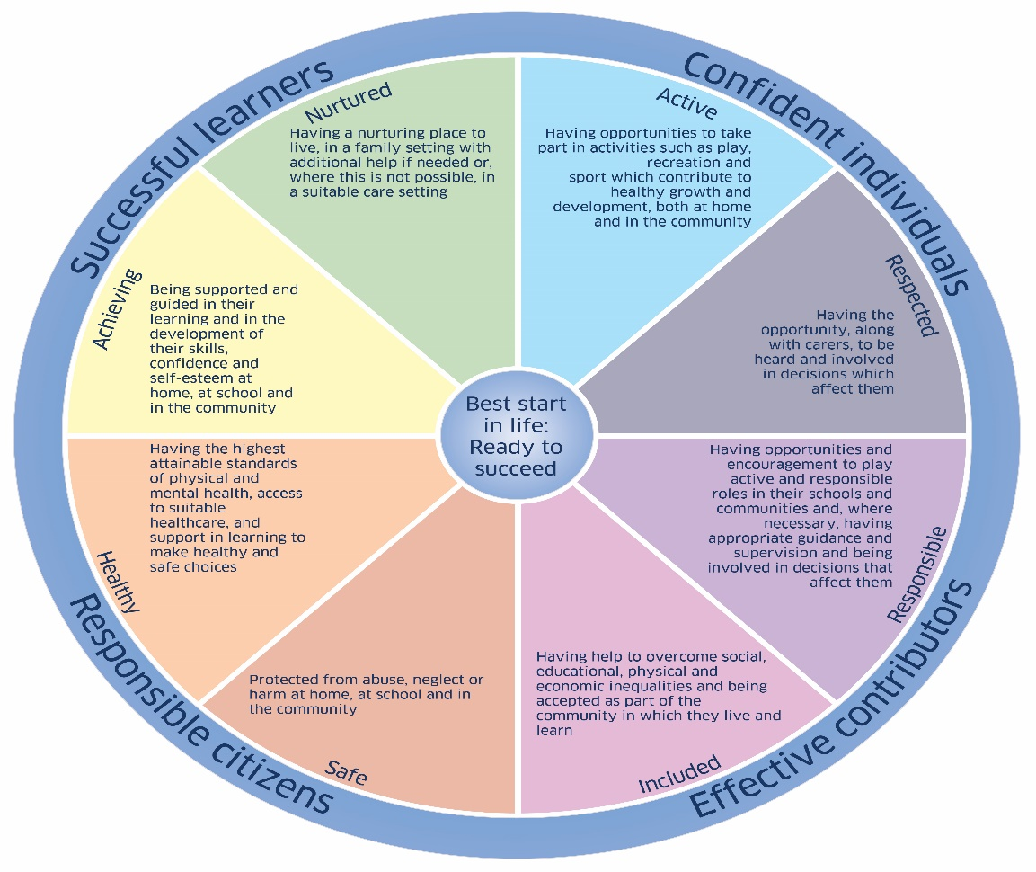

It is essential that in sport we understand not only how participation in sport contributes to these wellbeing indicators, but also what we need to do if we are ever worried that something is impacting a child’s wellbeing.

Child wellbeing concerns in isolation do not always meet the threshold for a child protection referral but still have an impact on the wellbeing of the child or young person. A range of experiences can have negative effects on children and young people, for example bullying, mental health concerns, bereavement, family separation or parents pushing their child too hard in sport.

There may also be scenarios where a volunteer or member of staff could have an impact on the wellbeing of a child or young person due to their poor practice. Examples may include shouting aggressively, punishing children and young people through extra drills/exercises, singling children and young people out in front of peers for minor things such as leaving kit behind, or communicating with children and young people through a personal social media account.

It is important to note that child wellbeing concerns may, with further exploration or over time, escalate to become more significant child protection concerns and therefore it is important to respond appropriately and at the earliest opportunity.

It can be helpful when considering a concern about a child or young person in your organisation to refer to the wellbeing wheel to identify which of the indicators are being affected by the experience of that child or young person. If at any stage a concern about a child or young person requires escalation to social work, they may ask which SHANARRI indicators you are concerned about.

As part of the Children and Young People (Scotland) Act 2014, the concept of wellbeing, SHANARRI and the GIRFEC approach are enshrined in law.

Source: www.gov.scot/Topics/People/Young-People/gettingitright/wellbeing

