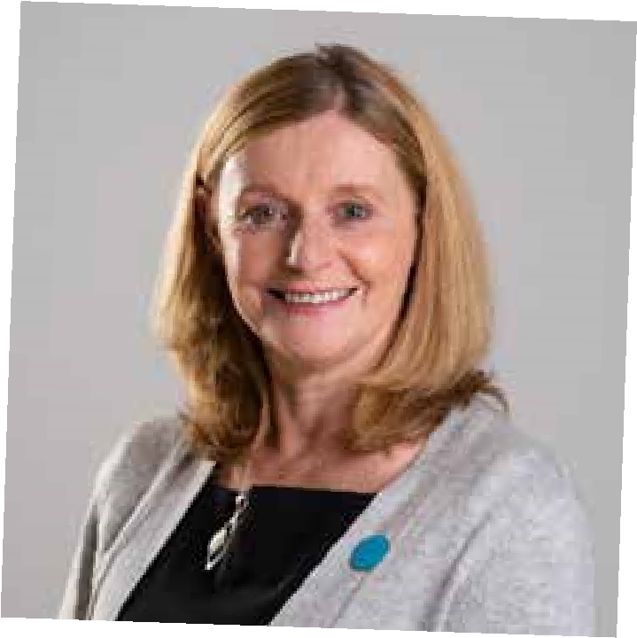
Appointment of Assistant Director
L
i
n
d
a

Ja
rdi
n
e

Children and Family Services – Based in Glasgow Area
Hello,
I am thrilled that so many people tell us they want to come and work with us at Children 1st. It might be that they know about our amazing work alongside children and families, or they may have seen the way we have successfully influenced policy and legislation. They might have taken part in some of our great fundraising campaigns. For many of them what tends to be their main reason for working with us is the same thing that I love about Children 1st: our strong value base, and our vision for transforming children’s lives.

Our values and vision give us a clear “why”- to keep children safe in their own families and communities. Our rich history of 140years means that we have a very strong sense of purpose. We have a pride in our heritage, but it does not make us traditional or dull, we are creative and innovative.
We are a good size, not too big – so we are well connected to each other and everyone here is in touch with children and families we work alongside. We are big enough to get things done, to make a difference and to transform the lives of Scotland’s children. Our shared sense of purpose means every colleague and volunteer in our team makes a difference for the children we support. Whether it’s in our service teams, our IT, finance, admin or fundraising teams – everybody contributes.
It’s simple for us - If we do right by children, we do right by Children 1st.
Our clear purpose, our amazing people, our strong culture and values means we achieve great things for children and I believe it’s why so many great people come and work with us. Our colleagues tell us all the time that they love working for Children 1st, here are a few comments:
“The Leadership Teams are very understanding and want staff to make families their priority and give the encouragement and autonomy to do this”
- Mhairi, Project Worker
“I feel very proud to be working for the organisation, the support from the top has weaved it’s way down empowering everyone at Children 1st to support families in the best way possible way.”
- Fran, Coordinator
What kind of person will make a great Assistant Director for Children 1st?
I know exactly what we are looking for, someone who:
- has experience of keeping children safe in their own families
- is fiercely passionate about children’s rights
- thinks it’s a privilege to work with and on behalf of children and families and,
- is kind and will bring their whole selves to the job: heart and mind
What kind of leader will you be?
You will be someone who is:
- resilient, skilled and knowledgeable who wants to transform systems as well as children’s lives
- big hearted and courageous
- able to build great partnerships and to manage the tricky conversations
- able to understand, predict and adapt to the landscape
- bringing deep level operational service experience
- a cool head and clear minded at times of pressure
- strategic in decisions and planning and can manage complexity
- inspiring colleagues and teams to be even better
- an amazing ambassador for children and Children 1st
Above all else, you are someone who will do the right thing for children and their families at every turn.
Why Children 1st?
Because we believe in providing support to whole families through strong trusting relationships to keep children where they are safe and loved. We don’t “do to” families, we respect that with the right support, families can usually resolve their own difficulties and overcome challenges.

We have local services in communities and national services that stretch across the whole of Scotland that make a lasting difference to children’s lives. Just as important as our community based supports is our work to amplify the voices of children, their parents and carers to ensure they have real influence and power to change how things are done.
Children 1st have always worked from a trauma recovery approach. We believe it is the power of strong relationships that makes repair and recovery possible.

The Assistant Director role is not for the faint hearted it’s a big commitment and responsibility. We are relentlessly focussed on quality and we are constantly looking to improve. You will find this role a challenge and you will be stretched. You will also find we are a kind and an incredibly supportive organisation.

Protecting Children
Whilst there will be many demands on you, I will expect that you will never lose sight of the need to protect children. You will make sure that we are compassionate in our response and accountable to children, families and stakeholders. You will demonstrate an unwavering focus on the needs of children and to work to protect key attachments. I expect nothing less of myself and our team.

Diversity and inclusion
We seek to tackle all forms of discrimination, including on the basis of ethnic origin, sexual orientation, gender and disability, both internally and externally. However we recognise that we are not yet fully representative as we want to be and we are challenging ourselves as an organisation every day in our accessibility, our language and our ingrained and unconscious bias. In doing so I find the words of Maya Angelou helpful: ‘We are seeking to know better so we can do better.’

Base
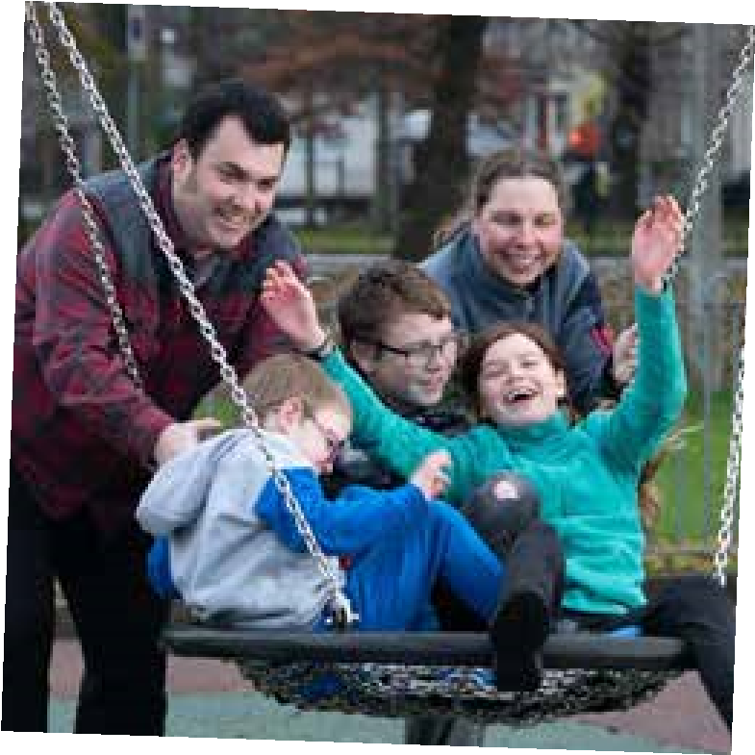
You will be based in the Glasgow Service and will travel to connect with other services and parts of the organisation.

Wellbeing
Your wellbeing is important to us, we will support you to work in a way that gets the job done but maintains a healthy work life balance. We will provide connection with the rest of the organisation and regular support from me, Assistant Director colleagues and colleagues in the Senior and Executive Leadership Team.

Salary, Conditions, Pension
We will offer you a competitive salary £57,000 to £64,000,
generous annual leave entitlement (40 days inclusive of 9 public holidays), flexible working opportunities and a contributory pension scheme. Additional benefits include a cash-back health plan, cycle to work scheme and opportunity to join Glasgow Credit Union.

You will join a high-functioning team of leaders, who contribute to a culture of high support. Additionally, as a leader in Children 1st, you will benefit from our commitment to your development as a leader.

I really look forward to hearing from you, please get in touch if you want to know more : linda.jardine@children1st.org.uk

Linda
Linda Jardine
Director of Children and Families, Children 1st

