Safeguarder Allocation Process

Frequently Asked Questions

How does the Allocation System work?

The taxi rank system is a database made up of a number of lists covering each local authority area. Every Safeguarder will be listed in alphabetical order on each of their preferred local authority area lists as chosen on appointment to the national Safeguarders Panel. This allows each list to run at different speeds dependent on appointment level as well as allowing the appointment process to be as transparent as possible. Levels of appointments vary from area to area. Below is a template of the system that is presently in use:

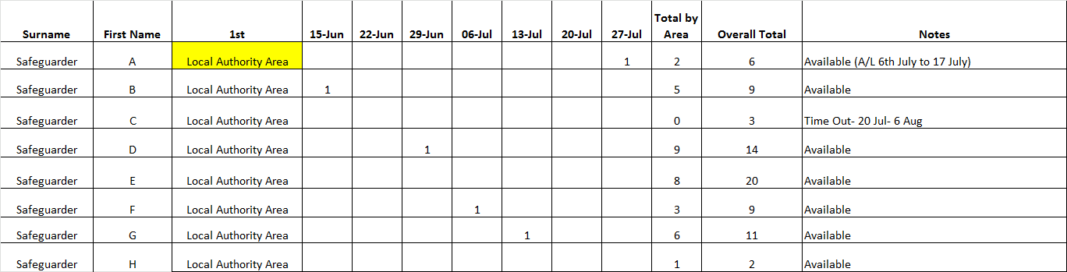

An allotted time of three hours is given to respond to an allocation request. It is understood that this is a short time scale to adhere to, however there is an expectation that a child will be allocated a Safeguarder within two working days.

The system has been developed to highlight not only the last person to accept an appointment for each local authority area but also any Safeguarder that has been reappointed or unable to take an appointment. Any Safeguarders that are reappointed to a case or are allocated out of sync of the taxi rank will be highlighted appropriately and omitted from their next turn in the ranking system. Those Safeguarders who have advised the team that they are unable to take a case, whether it is due to a period of annual leave or other commitments on that date, will be highlighted and approached with the next appointment on return in order to ensure that they are not disadvantaged.

Those Safeguarders responding too late to an allocation can request to keep their place in the taxi rank for the next appointment; however Safeguarders who do not respond to requests will lose their place in the taxi rank system until the next time they appear at the top of the list.

Reappointments

Safeguarders will always be approached for cases that they have been previously involved in. It is up to the Safeguarder to decide whether their continued involvement is in the best interests of the child. The only exception to this rule is if the child requests a different Safeguarder. If this occurs the Safeguarder will be informed of the reasons and decision to do so. If a Safeguarder is on time out then they will not be approached for a reappointment unless they have specifically requested that we do so.

Can I change my 1st/2nd choices areas?

These areas were agreed upon on appointment to the national Safeguarders Panel and are dependant upon operational need. Only in exceptional circumstances will a Safeguarder be approached to accept a case from their 2nd choice areas or from further afield.

Any requests to change geographical areas will be considered against the criteria above.

What information is provided to the Safeguarders Panel Team?

The case specific information given to the Safeguarders Panel Team is passed on to the Safeguarder once an appointment has been accepted. Service user names can be provided on request. The details that are provided to the Safeguarder once an appointment has been accepted are the only information the Safeguarders Panel Team hold.

What should I do if I am going on Annual Leave?

Safeguarders should indicate any periods of absence by email, text or phone. Public holidays, such as Christmas, are a time when numbers of available Safeguarders are lower and opening hours across partner agencies are varied. Advance warning of any annual leave over these periods is beneficial to the smooth running of the service and will not negatively affect Safeguarders’ case levels. Those who are unavailable at their turn in the taxi rank due to annual leave will be approached for cases when they return.

What is Time Out?

Time out is a mechanism used to allow Safeguarders to take a break in accepting appointments without prejudicing their position in the taxi rank system. Many have found this tool to be useful when addressing illness or busy periods in their personal or work life.

Working in tandem with the taxi ranking system any Safeguarder that requests time out will not disadvantage Safeguarders as their place in the queue will remain until they return.

All Time Out needs to be mutually agreed upon with the Allocations Coordinator, Francesca Howard, the Safeguarder and the Service Managers.

What should I do if I cannot continue with an appointment?

In the event that a Safeguarder cannot continue with an appointment such as a conflict of interest or illness, the Safeguarder must contact the relevant agency that first appointed them and inform them of their withdrawal. It is requested that you also inform the Safeguarders Panel Team in order for us to track the progress of this reallocation. It would be beneficial to the speed of the reallocation if Safeguarders could request that the relevant agency submit a fresh request form to the Safeguarders Panel Team.

Should all appointments come through the Safeguarders Panel Team?

All Safeguarder appointments under the 2011 Act must be allocated through the Safeguarders Panel Team as per the agreement with SCTS and SCRA. Safeguarders should accept 2011 appointments only from Safeguarders Panel Team and approaches by other parties should be redirected to the Safeguarders Panel Team in line with your letter of appointment as a member of the national Safeguarders Panel.

What happens if I move or change my contact details?

It is important that Safeguarders keep the Safeguarders Panel Team up to date with any changes in their contact details. We share the details that you provide us with SCRA/SCTS when allocating you to a case and these details will be used to send the papers out to you. To prevent a possible data breach it is imperative that you get in contact with the team as soon as possible.

